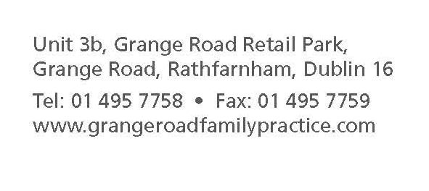
Patient Registration Form
- Name: ___________________________ Date:______________

- Gender? Circle. Male / Female

- Date of Birth: ___/ ___/ ____

- Address: _______________________________________________________
_______________________________________________________
5. Contact number: (a) Home: ___________ (b) Mobile: _____________
6. Do you have a medical card or doctor visit card? Circle. NO / YES
7. If ‘YES’, please provide your medical card number: ______________
8. Next of Kin: Name: ____________________
Contact Number: _________________________
Relationship to you: ___________________________

9. Please list any known Allergies: __________________________
10. Email address: ________________________
11. How did you hear about us? _______________________________________________

*If you would like your Medical Records to be transferred to our practice, please could you ask our Receptionist to provide you with a Request Form for Signature and we would be happy to send it off for you.

Please turn over for GDPR consent

Personal Data Consent Form (Please fill in fully)
Name: ………………………
DOB: ……………………….
Signature: _____________________________
Under the new data protection law which came into effect on 25th May 2018, we are required to ask of you to opt in or out of the way we communicate with other health professionals. Please ensure that all sections are completed:
Do you consent to the following?
Text Messages
Appointment Notifications/Reminders (when available) Yes No

Email, Post & Fax
Sometimes we need to send personal information relating to you to different organisations e.g. referral letters/test results to consultants/Solicitors/Dept of Social Welfare/ transferring your medical file to a new GP on request. Do you consent us sharing your personal data in the following ways:

By Health-mail, a secure encrypted email only for health professionals: Yes No

By Post (to hospitals/solicitors etc): Yes No

By fax (to hospitals/solicitors): Yes No

Consent for collecting personal data on my behalf from this surgery: (Include pharmacy if relevant)
(Your name) (Spouse/friend/relative name)
I, ___________________________ give my consent for____________________________

To collect my prescription Yes No

To collect my sick cert Yes No

To request my blood test/scan results Yes No
Please note that you are entitled to opt out of consenting to any of the above methods of sharing your personal data at any time. *We recommend speaking with your GP before opting out of this.
If you do not wish to sign this form, please be aware we will no longer be able to send your details to any professional colleagues if referring you for further testing/treatment.
** If you would like to have a read of our practice privacy statement, please ask at reception**

